

CSF3133 WEB-BASED INTERFACE DESIGN (K4)
LAB MODULE 6
SEMESTER III 2025/2026

PREPARED BY:
AIDA HUSNA BINTI MUHAMAD ZAIDI

NO MATRIK:
S76103

LECTURER:
TS. DR. WAN NURAL JAWAHIR BINTI HJ WAN YUSOF

LAB MODERATOR:
PN. WAN FATIN FATIHAH BINTI YAHYA

6.3 Basic JavaScript
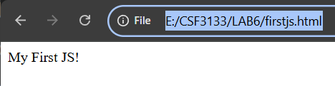
After change the statement document.write(“My First JS!”) into: document.write(“<b> My Fisrt </b>” + “<i>Java Script</i>”);
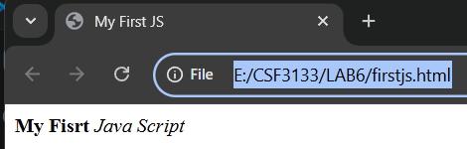

6.4 getElementById()
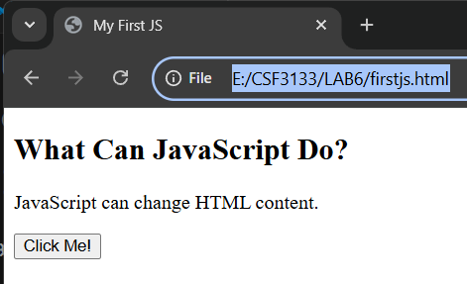
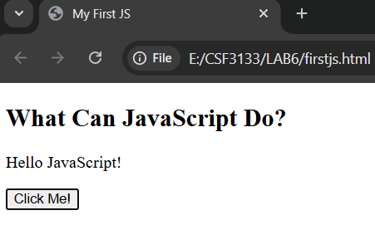
6.4 Date and Time
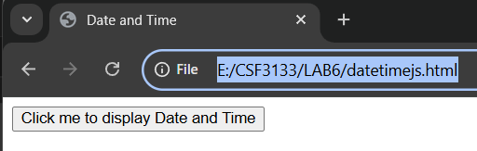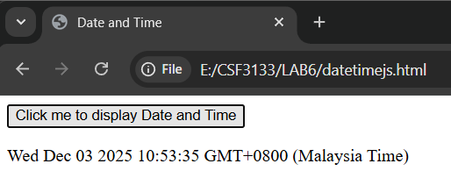

Add these script to change the style of variable(demo):
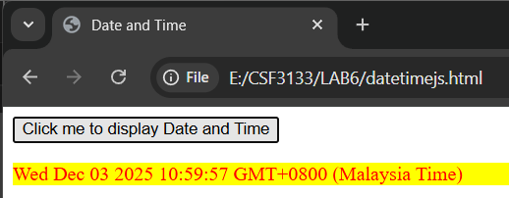

6.6 Change the HTML Attribute Value
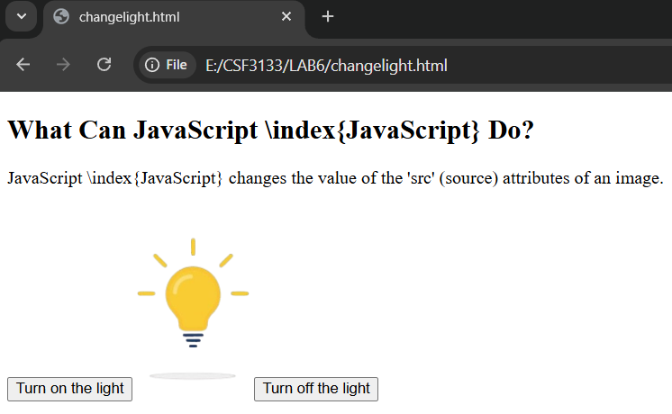
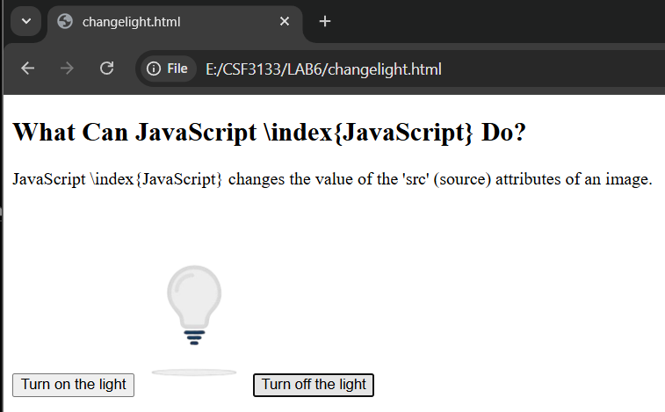

6.7 Link to file Javascript
6.7.3 External References
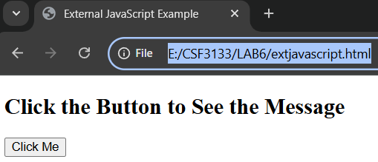
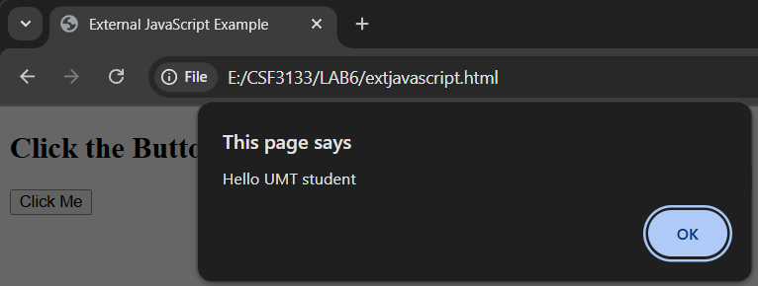

6.8 Working with event
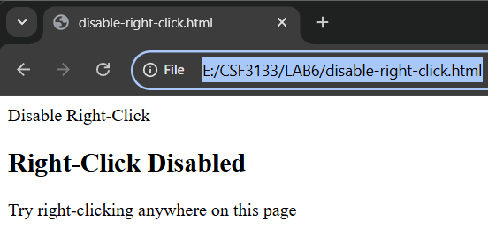

6.9 Multiplication Table
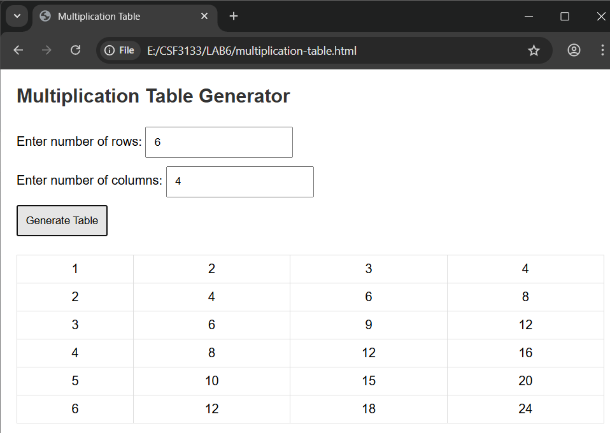
6.10 Client-side validation
6.10.1 Form Validation
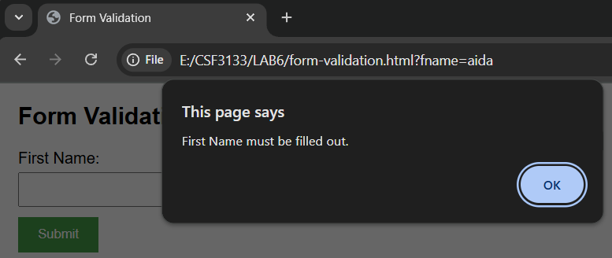
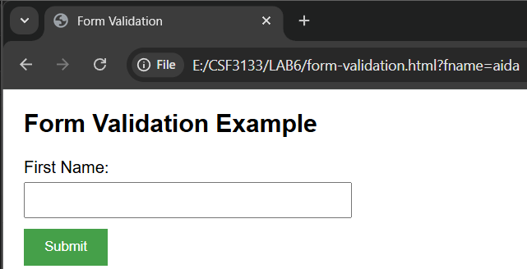

6.10.2 Numeric Input Validation
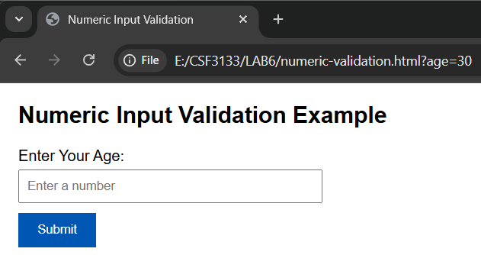
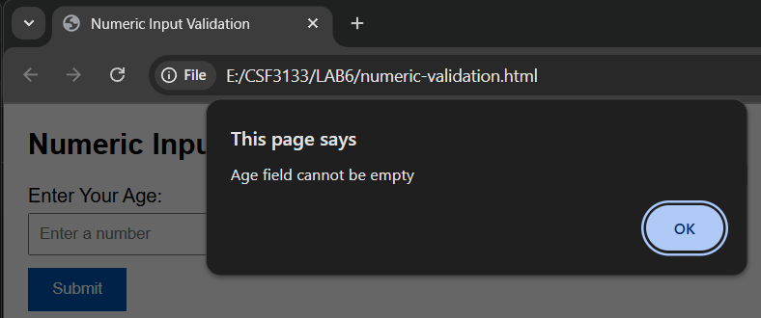
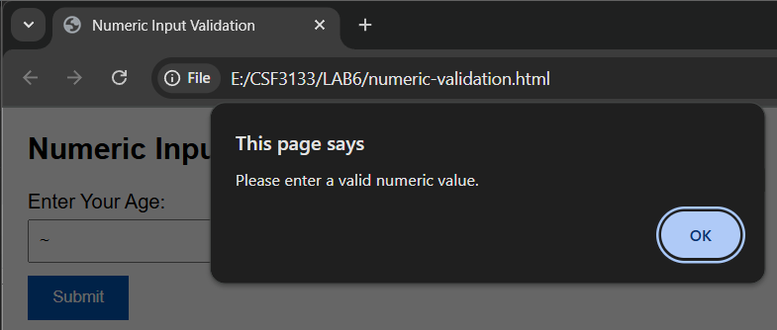

6.11.1 Guess a Number
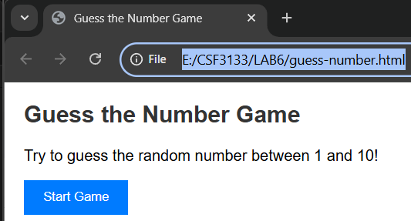
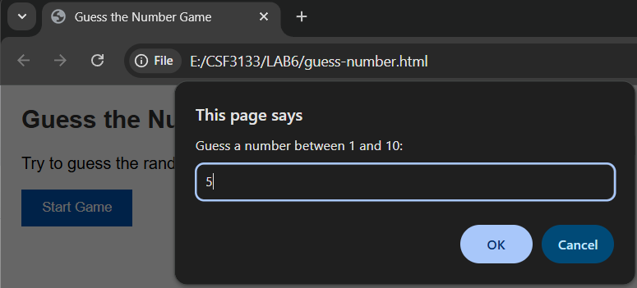
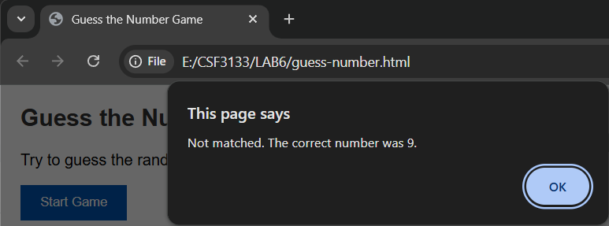

Lab Exercise
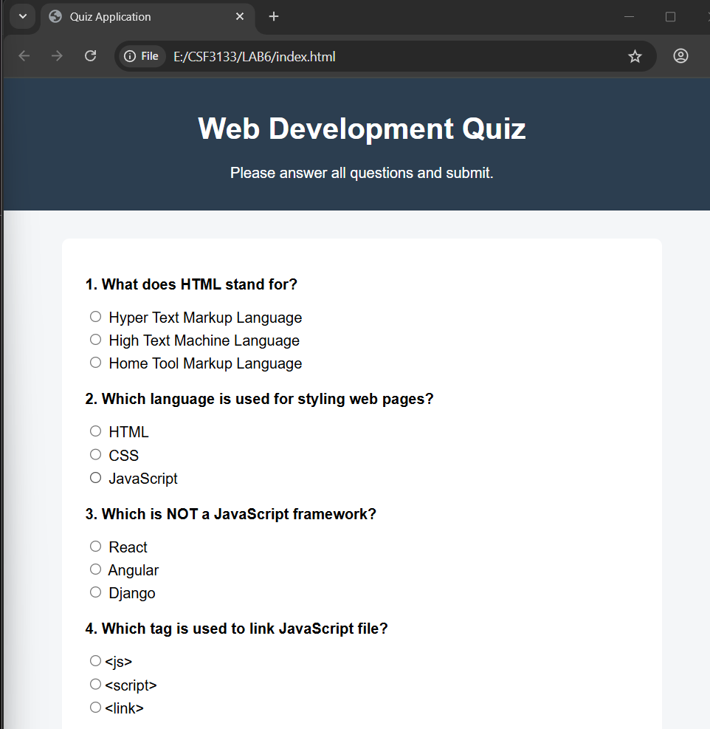

After click the Submit
